Please be sure to do your online shopping through schoolstore.com

# Dates/Times to Remember

**March**

**2-**Dress-Up Day/Dr. Seuss B-Day

**3-**Dress-Up Day

**4-**Dress-Up Day/Family Movie Night

**5-**Dress-Up Day

**9**-Spirit Night Texas Roadhouse

**9-**SAC Meeting 2:30 pm (Virtual)

**12-**Field Day/Kona Ice Day

**15-19-**Spring Break!!!

**30-**FSA Family Night (Virtual)

**April**

**1-**End of 3rd Nine Weeks

**2-**Good Friday (No School)

**5-**Planning Day (may be ice day MU)

**6**-FSA 3rd Grade Rdg

**7**-FSA 3rd Grade Rdg

**7-**Spring Pics/6th Grade Pics

**8**-FSA 4th & 6th Writing

**9-**FSA 5th Grade Writing

**15-**Report Cards/Kona Ice Day

**27-**Kindergarten Registration 8-6



The Chumuckla Elementary School Improvement Plan and Parent Involvement Plan are available for your review on our school’s web site chumucklaelementary.com. Copies of the plans are also available in our Parent Resource Center located just outside the front office. To obtain a paper copy of the District Family Engagement plan, please contact Patti McKnight at [mcknightp@santarosa.k12.fl.us](mailto:mcknightp@santarosa.k12.fl.us)or (850) 983-5001. Parent input regarding the School Improvement Plan and Parent Involvement Plan is always welcome!  Parent participation in our School Advisory Council meetings is also encouraged. **Our next SAC meeting is March 9, 2021 at 2:30 pm.**

Greetings CES Families,

It seems hard to believe, but we are just a few short days from the beginning of Spring Break 2021! Whether you are a cold weather person or not, I hope that you have enjoyed some of the spring-like weather we have been having. Couple the warmer weather with the full moon, and you can only imagine what it has been like here. (lol) Everyone is still working diligently getting prepared for what we refer to in the education world as “Assessment Season.” Whether it will be the Florida Standards Assessment (FSA) or the STAR reading and math test, these tests help to provide a way for us to determine the level of growth students have made during the school year. The optimal goal is for each student to make a “year’s worth of growth.” Of course, anything beyond this is even more cause for celebration. Also, whether or not the Florida Dept of Education is planning to count learning gains this year, we still feel learning gains are important, because that helps us to know what instructional adjustments need to be made. You can see part of list of the FSA tests our students will take this spring on the right. I want to let everyone know that has a kindergartner beginning school for 2021-2022, that you will need to go to the district website to the Focus portal to register. On this site you will upload the required documents to complete registration. By April 1, you will be able to access this list of documents on the CES website. If you do not have access to a device to register online, or you have trouble uploading the required documents, you may come to the school between 8:00 am and 6:00 pm on Tuesday, April 27**. Please note: To receive assistance for registration on this day from 3:00 pm-6:00 pm you will need an appointment. Please call Lore Conway to make an appointment for times between 3:00 and 6:00 pm. You may even call the same day as long as you call before 12:00 pm.** You will not need to bring your student to the school on this day. Once registration is complete, you will be contacted by the kindergarten teachers to schedule a day during mid to late July for academic screening. In addition, there are required immunizations for 6th grade students to advance to the 7th grade. There will be more information sent home about this soon. Finally, we hope that you will allow your student to participate in our next Kona Ice Day coming up March 12. CES receives 30% of all sales, so this is a great on-going fundraiser for our students. As always, Mrs. Baggett and I thank you for all your support, especially during these most unprecedented times.

Lighting a Path to Success for Every Child, Every Day! Danny Carnley, Principal

# **From The Chief’s Desk**

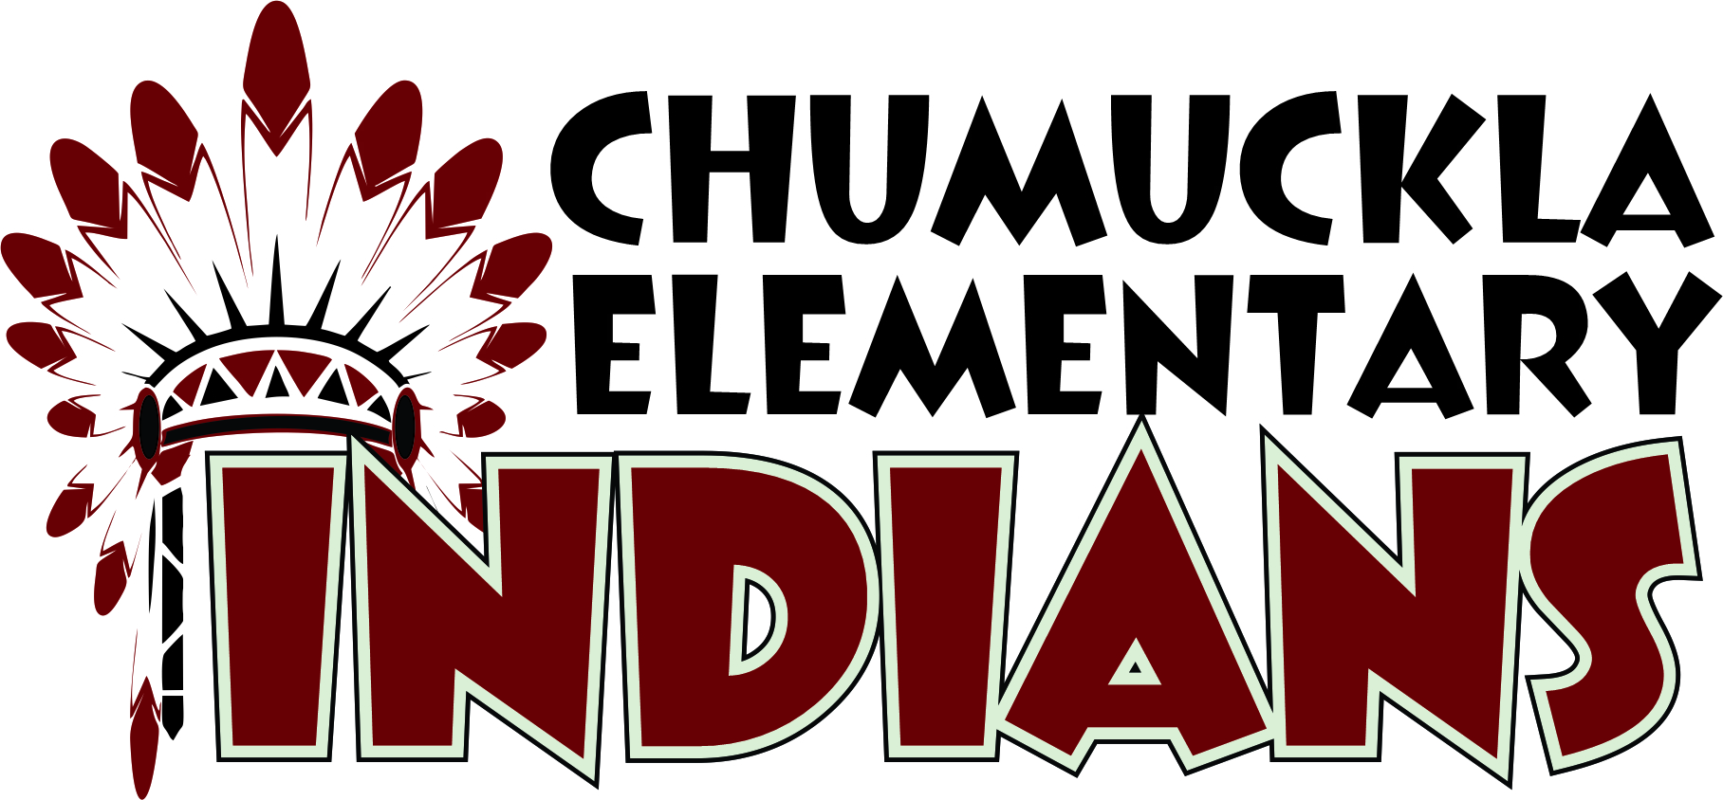

Tribal Tidings

|  |  |
| --- | --- |
| **2/26/2021** | Volume 8, Issue 6 |

**Good afternoon CES families and friends,**

**Wow, this year will be gone before we know it and I feel like we just got started! Time is flying so fast! Now we just need some warmer, dryer weather.**

**I would like to start by thanking everyone who helped us raise money at our Buffalo Junction Spirit Night. We use these funds to help with rewarding our students at the end of each nine weeks (Tribal Days) and we also use those funds to celebrate our teachers and all the hard work they do. Thank you for all your support!! I also want to take a moment and ask all parents to remind students how important instruction is in the classroom. Please review our Tribe Expectations with your child. Testing season is right around the corner and teachers are diligently trying to cover all curriculum in a timely manner and behaviors may hinder the instruction or the learning environment.**

**TRIBE EXPECTATIONS**

**T**RUSTWORTHY

**R**ESPECTFUL**, R**ESPONSIBLE

**I**NDIANS

**B**ELIEVE IN

**E**XCELLENCE**!**

**We have some exciting events coming up! Dr. Seuss week is March 1-5. Thursday, March 4th is a Title 1 Parent and Family Engagement Movie night. We hope everyone will be able to come join us. All week students will be participating in Dr. Seuss literacy activities in the classroom. We will be sharing those with you on our big screen along with our Dr. Seuss readings and a movie!**

**Spring Break will be here March 15-19 and we hope you all have a wonderful and safe break!**

**Please let us know if we can assist you in any way.**

**Lighting a Path to Success, For Every Child, Every Day,**

**Mrs. Baggett**

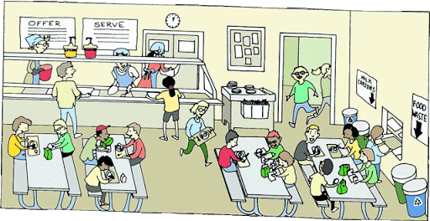

**CAFETERIA**

**TRIBE RULES**

**T**alk quietly after you are finished eating.

**R**emain seated, on bottom, at all times.

**I**gnore distractions.

**B**e prepared and respectful

**E**at with good manners.

**A.P.’s Powwow**

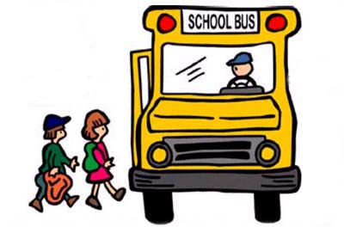 ***Bus Safety Rules & Expectations***

* Wait for bus to stop before approaching
* Buckle Up
* Remain seated at all times, raise/wave your hand for assistance.
* Quiet Voices
* Do not change seats unless bus driver tells you to.
* Feet out of aisle
* Remember if the lights are on- NO TALKING
* Must keep mask on at all times.

***Indian Star Students***

The following students received a Positive Student Referral this Month

***Mason Lane*- Mrs. Retzlaff**

**Jaci Perritt- Mrs. Retzlaff**

**Alathia Rogers- Mrs. Anderson**

**Elara Taylor- Mrs. McDonald**

**Noah Wales- Mrs. McDonald**

